Day in the Life of the Hudson River 10/13/22
Francis Lewis Park, Queens, NY
East RIVER MILE: 13.7
HR Salt Front: ~ RM 76
Pelham Preparatory Academy– Zachary Itzkowitz
New York City Park Rangers – Rangers Jonathan Kovaks, Joseph Czeisel
DEC Region 2 – Andrew Snyder
24 students & 8 adults
Latitude 40.797289°N & Longitude – 73.826217°W
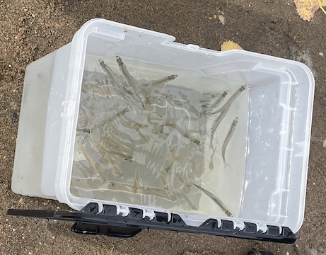
Atlantic Silversides
Location: Francis Lewis Park, Queens, NY
Area: Near the Whitestone Bridge
Sampling Site: Pier, grassy, beach
Surrounding Land Uses: Urban/Residential, Beach
Shoreline: Sandy
River Bottom: Sandy
Water: Calm
Plants in the Water: No plants in the water
*NR = Not read/recorded
ITEM |  | Time |  | Reading |  |  |  | Comments
Physical
Air Temperature- |  | 11:26 AM |  | 26.1°C |  |  | 79°F
Wind Speed: |  | 11:27 AM  11:30 AM |  | Anemometer  4.2 mph  6.9 mph |  |  | Beaufort  NR | Direction  N  S
Weather today |  | 11:26 AM |  | >75% cloud cover |  |  | Drizzle
Weather the past 3 days: |  | Sunny, no rain
Tides- |  | Time |  | Rising, Falling, Unchanged |  |  | Water Height (cm)
 |  | 11:50 AM 12:01 PM  12:30 PM  12:40 PM |  | Rising  Rising  Rising  Rising |  |  | 25 cm  38 cm  63 cm  70 cm
Current- |  | Time |  | Cm/sec |  | Knots | North/South | Ebb/Flood/Still
*in a cove |  | 11:53 AM |  | 14.3 |  | NR | NR | NR
Water Temperature- |  | 11:30 AM |  | 18.9°C |  |  | 66°F
Turbidity- Long Sight Tube (120 cm) |  | 11:44 AM |  | - 120 cm |  |  | Exceeded the height of the tube
Chemical
Salinity-Hydrometer |  | 11:32 AM |  | 26 ppt
Standardized Salinity – Refractometer |  | 10:26 AM |  | 26 ppt
DO – Hach Drop Count Kit |  | Time  12:31 PM |  | Temp  18.9°C |  |  | ppm DO  7 ppm | % saturation  75%
pH – Color Match Kit |  | 11:37 AM |  | 7.6
Nitrates- water sample kit |  | NR |  | 3.5 ppm
Phosphates- water sample kit |  | NR |  | 0.5 ppm
Alkalinity- NR
Biological-
Fish – Seine 10-15 times |  | Number |  | Name |  |  | Length of longest | Length of smallest
11:22 AM-12:30 PM |  | 250 |  | Atlantic Silverside
Fish Totals |  | TOTAL: 250 |  | Diversity: 1
Macroinvertebrates |  | Number |  | Name |  |  | Length of longest | Length of smallest
 |  | 2 |  | Hermit Crab
Macroinvertebrate Totals |  | TOTAL: 2 |  | Diversity:1
Sediment Core –
Length | H2S smell |  | Oxid Top |  | Oil |  | Grain Size | Other Features
NR | NR |  | No |  | No |  | Abundant: sand  Common: gravel, pebbles | Common: leaves, shells  Rare: wood
Boats-
 | Time |  | Name |  | Color |  | North/Southbound | Light/Loaded
Commercial | 11:22 AM  11:23 AM  11:25 AM |  | NA  NA  NA |  | White  Blue/White  White |  | Westbound  Eastbound  Westbound | Light  Light  Light
Recreational

